National Child Measurement Programme: Gloucestershire Privacy Notice

Introduction
If your child is participating in the National Child Measurement Programme (NCMP) in Gloucestershire schools, please take time to read this Privacy Notice.

What is a Privacy Notice?
A Privacy Notice is a statement issued by an organisation which explains how personal and confidential data about individuals is collected, used and shared.

Who is collecting and using your child’s personal data?
The information collected from all schools in the area will be gathered and held securely by Gloucestershire Health and Care NHS Foundation Trust (GHC). We will store your child’s information as part of their local child health record on the NHS’s child health information database. It will not be shared with the child’s school or with other children.

All the information collected about your child will be sent by us to NHS Digital. NHS Digital is responsible for collecting health and care information to check how the NHS and social care services are doing, and to use this to improve the care provided to people across England.

Your child’s personal data - what is it?
Personal data relates to a living individual who can be identified from that data. Identification can be by the information alone or in conjunction with any other information in the data controller’s possession or likely to come into such possession. The processing of data is governed by the General Data Protection Regulation 2016/679 (GDPR).
The purpose of this Privacy Notice is to tell you about what information we collect about your child as part of the NCMP, how we use that information, and who we may share it with.

What personal data do we collect?
The information collected by us includes a child’s height and weight measurements which we link with child health data we have with their name, date of birth, gender, home address and postcode, NHS Number and ethnicity.

This information about a child is needed because their age, gender, ethnicity and the place they live are known to affect their healthy growth. Their name, date of birth and NHS Number is needed to link the child’s measurements to other information about the child.

No individual measurements will be given to school staff or other children, and all information will be treated confidentially.

Who is your child’s personal information shared and why?
The information collected about your child will also be shared by NHS Digital with Public Health England but in a de-personalised form only. This means Public Health England will not be able to identify your child. Public Health England is responsible for working to protect and improve the nation’s health.

Both NHS Digital and Public Health England will use the information from the NCMP to better understand numbers and trends in children’s healthy growth across England. This helps with the planning of services to support healthy lifestyles in your area and nationally. No information will ever be published by NHS Digital or Public Health England that identifies your child.

De-personalised information from the NCMP may also be shared by NHS Digital with other organisations, such as universities. This is to help improve health, care and services through research and planning. This information cannot be used to identify your child, and NHS Digital only ever shares information for research with the approval of an independent group of experts.

“In order to better understand the health of children in Gloucestershire, we are supporting a local research project led by PhD Student Matthew Pearce. Over the next few months, you may be invited to complete a short questionnaire and we would be grateful if you could consider taking part.”

If your child was previously measured for the NCMP, NHS Digital may link your child’s current and previous measurements. It may also link their measurements with other information it holds about your child such as their dental survey results or the reasons for any visits they may have made to hospital. Linking your child’s information in this way helps better understand how and why the weight status of children is changing.

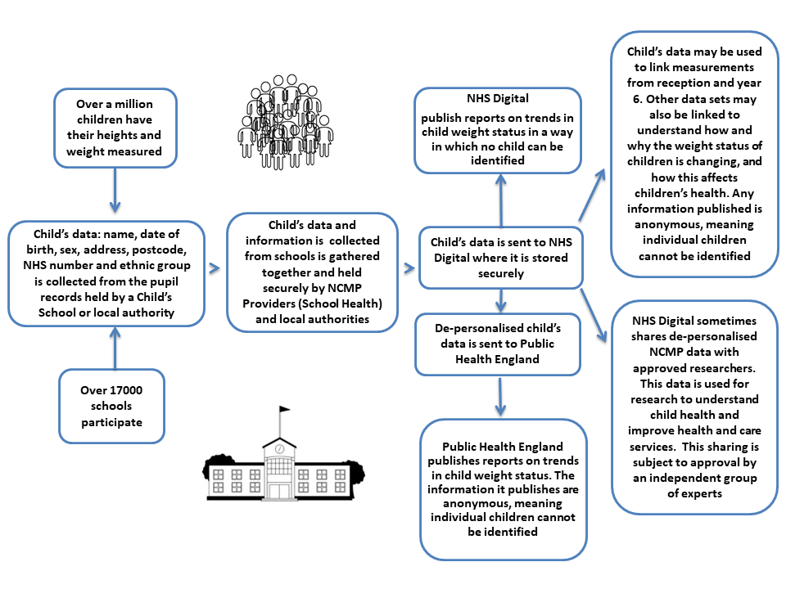
A visual representation of what happens to your child’s data as part of the NCMP is displayed below:

How the law allows us to use your child’s personal information?
The official authority for the NCMP is provided by The Local Authorities Public Health Functions and Entry to Premises by Local Healthwatch Representatives Regulations 2013 and The Local Authority Public Health, Health and Wellbeing Boards and Health Scrutiny Regulations 2013. This official authority means that the lawful basis for processing children’s personal data for this purpose is considered to be provided by:
- GDPR Article 6(1)(c) - processing is necessary for compliance with a legal obligation.
- GDPR Article 6(1)(e) - processing is necessary for the performance of a task carried out in the public interest or in the exercise of official authority.
- GDPR Article 9(2)(h) - processing is necessary for medical diagnosis, the provision of health or social care or treatment or the management of health or social care systems.

Consent is not the lawful basis for the processing of NCMP data. Parents/ carers can choose to opt their child out of the NCMP. Children will not be made to take part on the day of measurements if they do not want to.

How do we protect your child’s information?
GHC complies with its obligations under the GDPR. This means it keeps personal data is:
- stored and destroyed securely,
- not collected or retained excessively,
- protected from loss, misuse, unauthorised access and disclosure,
- protected with appropriate technical measures in place.

How long do we keep your child’s personal information?
Your child’s data will be kept for six years after collection. This is in accordance with the Trust’s Data Retention and Disposal policy.

What can you do with your child’s information?
Your personal information belongs to you, and you have the right to:
- be informed of how we will process it;
- request a copy of what we hold about you and in commonly used electronic format if you wish (if you provided this to us electronically for automated processing, we will return it in the same way);
- have it amended if it is incorrect or incomplete;
- have it deleted (where we do not have a legal requirement to retain it);
- withdraw your consent if you no longer wish us to process;
- restrict how we process it;
- object to us using it for marketing or research purposes;
- object to us using it in relation to a legal task or in the exercise of an official authority;
- request that a person reviews an automated decision where it has had an adverse effect on you.

If you would like to access any of the information we hold about you or have concerns regarding the way we have processed your information please contact: InfoGov@ghc.nhs.uk or by post to: Information Governance and Records, Team, Gloucestershire Health and Care NHS Foundation Trust, Edward Jenner Court, 1010 Pioneer Avenue, Brockworth, Gloucester, GL3 4AW.

Your right to complain
You also have a right of complaint to the Information Commissioner’s Office (ICO) at www.ico.org.uk if you think we have dealt with personal data or information in an inappropriate manner.
Any further questions regarding the data being processed may also be sent to the Data Protection Officer at GHC: InfoGov@ghc.nhs.uk .

What if you do not provide personal data?
How will GHC ensure compliance? A yearly audit will take place to ensure that we remain legally compliant in accordance with current data protection legislation and NCMP national guidance.

Main Privacy Notice
You are viewing the Privacy Notice for National Child Measurement Programme, you can access the main Privacy Notice for GHC, here.

