ATTENTION AND LISTENING

STRATEGIES AND ACTIVITIES TO TRY AT HOME

HOW IT HELPS
Children need to be able to listen and pay attention to sounds and words used around them to help them learn to talk and communicate.

Many young children have a short attention and cannot concentrate for very long. For some children with communication difficulties, concentrating can be very tricky.

Your child may need extra help learning to listen and concentrate so that their speech and language can develop further.
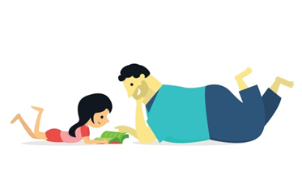
TOP TIPS
- Turn off the TV, phone, radio and even close windows when you’re playing together. Noise is distracting and hard for children to ignore and they will find it easier to listen and play in a quiet room.
- Put other toys away so there are only two or three to choose from. Lots of toys can be distracting!
- If you can, spend time playing with your child when other people are out of the house or babies are asleep. Then you can spend ten minutes playing with no distractions.
- Be face to face with your child so you can see the same things- this might mean lying on the floor!
- Wait for your child to look at you to show they are listening. It might help to hold their hand or call their name to get them to look.
IDEAS FOR PLAY
Here are some games you might like help your child’s attention and listening:
- Sit together in a quiet room and listen out for sounds you can hear (e.g. cars on the road, a dog barking, birds singing, clock ticking).

- Find a noisy toy or object (e.g. a loudly ticking clock) and hide it somewhere in the room. Play a game where you help your child look for it.
- Jack-in-the-box - All crouch down and spring up when you hear a drum bang or a clap.
- Musical Bumps/ Statues - Play music and sit down/ stand still when the music stops.
- Get matching instruments or noisy items (keys, pasta in a tub, crisp packet) and hide one of each behind a screen. Make one of them make a noise - can your child find the one that matches?
- Get matching farm animals and hide one of the animals under a box. Make the animal noise- can your child find the one that matches?
- Hide two or three objects while your child watches. See if they can go and find each object as you ask for it.
- Sing action songs like these: ‘Wheels on the Bus’, ‘Heads and Shoulders’, ‘Wind the bobbin up’, ‘Here we go round the mulberry bush’, ‘Incy Wincey spider’, ‘Two little dicky birds’ etc. Pause at exciting parts of the song and wait for your child to show you they want to keep going- they might do this by looking, moving their body, doing the action or making a noise.
