COMMENTING

STRATEGIES AND ACTIVITIES TO TRY AT HOME

HOW IT HELPS
Children learn to communicate by listening to people talk. Talking about what your child is doing will help this as it lets children hear words and phrases that are simple enough for them to understand and use. Try to imagine what your child might be thinking at that moment, and put it into words for them.
- Comment on your child’s play “pouring water!”
- Comment on what your child is looking at “Mummy’s cooking!”
- Comment on what your child is doing “up the steps, up up up, down the slide, wee!”
- Comment on other children’s play when near your child e.g. “uh oh – fell down!”
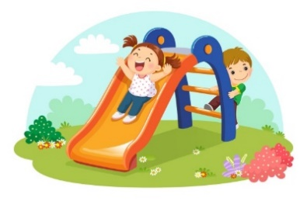
TOP TIPS
- Use “lead in” phrases e.g. “look at the…” “I see a…”
- Children love repetition so you can use the same words over and over again.
- Remember KISS - Keep It Short and Simple! Try to use the same number of words that your child uses. So if your child puts 3 words together, try using sentences with only 3 words.
- Talk about things that are happening now, for example, things that you are both looking at or doing together.

HOW TO CHANGE A QUESTION INTO A COMMENT
Instead of asking a QUESTION… | …. make a COMMENT!
‘What has happened to the cars?’ | ‘Cars crashed!’
‘What’s this?’ | ‘Look…brick’
‘Where has the cow gone?’ | ‘Cow’s under the bridge’
