DEVELOPING JOINT ATTENTION

STRATEGIES AND ACTIVITIES TO TRY AT HOME

WHAT IS JOINT ATTENTION?
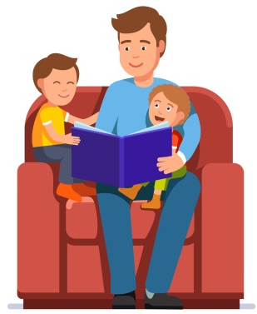
Joint attention is when two people share an interest in the same thing. It happens when one person shares the moment with another by making eye contact, pointing or using words / sounds to alert them to something they are looking at.
Examples of joint attention:
- When a child sees a plane, looks at their parent and looks back at the plane.
- When pointing to pictures when looking at a book together.
To use joint attention, a child needs to be able to let someone else to join in with their play. They also need to be able to move their attention between an adult and the object that they are interested in. This can be tricky for some children.
Joint attention is important because it builds early social skills of joining in a two-way interaction. It also allows the child to listen to and learn the language that the adult is using.
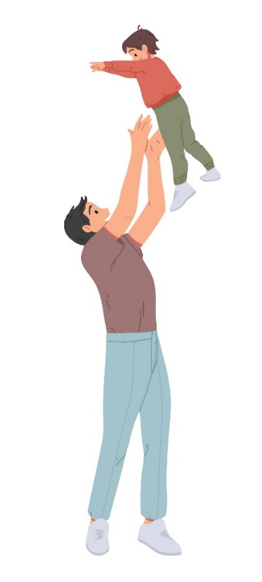
HOW DO I WORK ON THIS WITH MY CHILD?
- Make yourself a fun person to play with! Use a lively voice, lots of facial expressions and big gestures!
- Make eye contact as easy as possible for your child – kneel, sit or lie down so you are at the same level as they are.
- Play games that your child really enjoys, e.g. singing, bubbles and physical games to capture their attention.
- Join in with your child’s play and copy what they are doing with sounds and actions. Add in extra words and comment on what they are looking at.
- Point to pictures in books, toys or interesting things (e.g. the recycling lorry!) and say what you see.
- Encourage your child to move their attention between you and what you are both playing with.
- Encourage your child to look at your face and give you eye contact if possible. If your child really struggles to give eye contact don’t worry, joint attention can still be achieved.
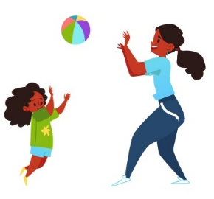
TOP TIPS
- Take turns in a game such as putting a puzzle piece in or rolling a ball down a ramp.
- Use toys that are hard to work, such as bubbles or wind-up toys- your child will need your help to work the toy!
- Practise in your daily routine, e.g. whilst brushing teeth, eating a snack or having a bath.
- Be creative – you could use a torch in a dark room to ‘look’ and point at different things.
- Practise when something unexpected happens, such as a tower falling over. Look at your child and make an exaggerated face, saying ‘wow!’, and watch for their response.
- Practise regularly.
- Give lots of praise when your child responds.
ACTIVITY IDEAS
These are just a few ideas:
- Roll a ball/car down a ramp or throw a ball back and forth
- Do a jigsaw together
- Sing songs with actions, like “Row, Row, Row Your Boat”
- Hold hands and dance to your child’s favourite song
- Hold a sheet or blanket with your child and rock a baby doll
- Blow bubbles
- Play Peepo or Hide and Seek with toys
- Blow up balloons and letting them go to fly around the room
- Physical games such as chase and tickles
- Build towers and knocking them down

