NHS Gloucestershire CGG – Falls Protocol – Residential/Nursing Homes

The Nurse-in-Charge/ Senior Member of staff must make an assessment of injury using the Post Fall Assessment Checklist (Appendix 1) prior to moving the resident

Minor/Injury

• Some bruising
• Slight skin wounds
• Slight discomfort
• No mobility problems able to move limbs on command and spontaneously (within pre-fall
range of movement)
• No head injury
• No signs of limb deformity/
shortening/ rotation

Major/Injury

• Loss of consciousness
• Reduced consciousness
• Signs of head injury
• Airway/breathing problems
• Haemorrhage / bleeding
• Chest pain
• Limb deformity
• Pain/discomfort
• Swelling
• Extensive bruising
• Unable to move limbs,
joints on command
• Dizziness or vomiting
• Any fall from height above
2 meters
• Any other concerns by
assessor.

Slight/Minor

• No apparent injury
• No head injury
• No complaints of
pain/discomfort
(verbal/nonverbal)
• Mobility unaffected able to
move limbs on command or
spontaneously
• No signs of bruising/
wounds
• No signs of limb
deformity/shortening
rotation

Administer first aid and assist resident to a comfortable place (using hoist/handling aid as required)
• Write up Post Falls Assessment using the Checklist in Appendix 1
• Observe resident for 24 hours for pain/and write it up
• Complete a body map
(Appendix 2) and document the details
• Inform relatives and document discussion
• Inform GP (FAX print out of Post Falls Assessment to Practice) and ask to see resident within next 5 days(unless deterioration)
•Inform Care Manager

- Assist resident to a
comfortable place (using
hoist/handling aid as
required)
• Write up Post Falls
Assessment using Checklist in Appendix 1.
• Observe resident for 24
hours for pain/and write up
• Complete a body map
(Appendix 2) and document

Do not move resident

• Call 999 for ambulance
• Inform relatives and document discussion in resident notes

Any change in condition causing concern, call GP in-hours or NHS 111 out of hours.
For Nursing Homes, qualified Nursing Staff can call the Health Care Professional Line on 0300 3690461

Complete Accident/Incident form and record in Resident’s care plan

POST FALL - ASSESSMENT CHECK LIST
Appendix 1

Date of Fall……………….………………………………….

Time of Fall………………............. AM/PM

Location of Fall………………………………………………

Level of Consciousness  (Check for head injury)  Select one option | - Responsive (verbal/other)  - Less responsive than usual  - Unresponsive/unconscious (call 999)
Pain/ Discomfort  Select one option | - No evidence of pain/discomfort  - Showing signs of pain (non verbal)  - Complaining of pain (verbal)  - Site of Pain (if any)
Injury/wounds  (check for open wounds, haemorrhage)  Select one option | - No evidence of bleeding  - Swelling/deformity  - Bruising/bleeding  - Site of Injury (if any)
Movement  (check for shortening or rotation of limb)  Select one option | - Able to move limbs on command (within pre-fall range of movement)  - Able to move but with pain  - Unable to move limbs on command or  Spontaneously
Observations  (Before moving if injury suspected)  Record each point | - Pulse  - Blood Sugar  - Blood Pressure
Mobility  Select one option | - Able to get up and weight bear  - Able to assist but showing signs of discomfort  - Unable to assist themselves up and requires hoist or other handling equipment.  - Major change in mobility and condition from pre-fall status?
Conclusion, Clinical  assessment and judgment  Select one  And complete all 3 points.  Conclusion, Clinical  assessment and judgment  Select one  And complete all 5 points  Conclusion, Clinical  assessment and judgment  Select one  And complete all 7 points | - Slight/Minor. If so,  - Document in Care Notes.  - Commence 24 hour observations.  - Commence individual assessments (see panel below)  - Minor/Injury. If so,  - Commence 24 hour observation  - Inform relatives and document in  Care Notes  - Inform GP and ask to see within  - days (FAX this form to surgery)  - Commence individual assessments (see panel below)  - Inform Care Manager  - Major/Injury. If so,  - Suspected/confirmed injury, call 999  - Inform relatives and document in  Care Notes  - First aid/resuscitate as appropriate  - Close observation until help arrives  - Provide ambulance staff with a copy of this form  - FAX form to GP surgery  - Inform Care Manager
Individual Assessments Required:
- Falls History
- Further risk of falls identified
- Medical state assessed
- BP/UTI?
- Medication
- Mental State Assessment
- Gait/Balance assessment
- Footwear/Foot care Assessment
- Eyesight /Hearing
- Toilet Requirements
- Environmental Audit/Telecare needs
- Do residents with dementia require more supervision and assistance

Appendix 2
Body Map – Assessment of Injury

Residents Name ………………………………………………………………..

Assessed by: ………………………………………………………………..
(Print Name)
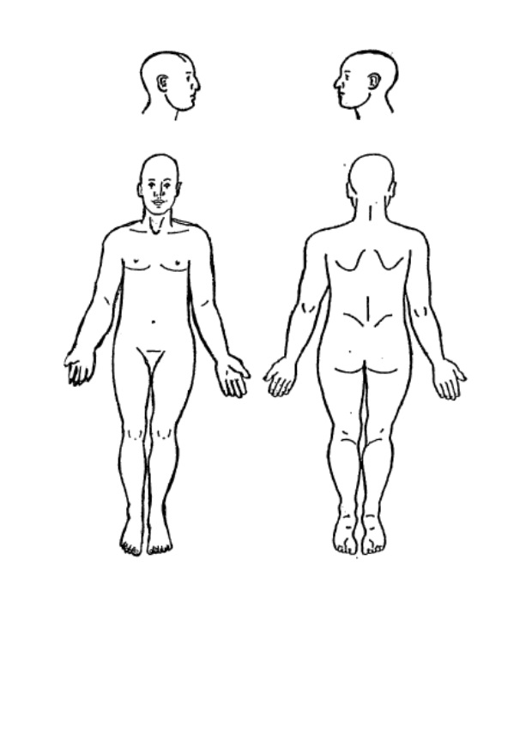

Marks or bruising on resident’s body (describe and mark on map above)

Date/Time _________________________________________________

Signature __________________________________________________

