ENCOURAGING UNDERSTANDING OF INSTRUCTIONS

THREE INFORMATION CARRYING WORDS (KEY WORDS)
KEY POINTS

- Three-year-old children usually understand three key words in instructions. For example, “Find your hat, coat and shoes”; “Show me the big green apple”. For a word to be ‘a key word’ there must be a choice available e.g. ‘big’ and ‘little’, ‘green’ and ‘yellow’, ‘apple’ and ‘banana’.

- Before you start these activities, check that the child knows colours and can understand the concepts ‘big’ and ‘little’; and ‘on’ and ‘under’.

- Remember, children often understand more words than they can say.

- Play these games during everyday activities (bath time, getting dressed and mealtimes). This will help the child learn words throughout the day.

- These games are to help the child understand words. You do not need to ask them to say the words.

- When playing these games try not to use gestures or pointing. This will help the child to learn to understand the words you are using.

UNDERSTANDING BODY PARTS VOCABULARY

BATHTIME
EQUIPMENT NEEDED  - Flannel/Sponge  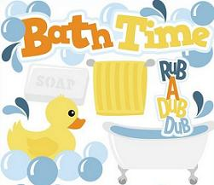  - SoapSection 4 | INSTRUCTIONS  Give the child instructions such as:  “Put soap on your arm and leg”  “Put water on your leg and hand”  “Put water on your nose and head”  “Put soap on your ears and toes”  “Put soap on your tummy and back”  “Put water on your hair and fingers”

POORLY TEDDY
EQUIPMENT NEEDED  - Teddy  - Dolly  - Big and Little Plasters  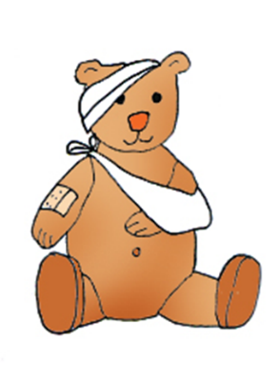 | INSTRUCTIONS  Tell the child that Teddy and Dolly have fallen over and hurt themselves. Give the child instructions as to where to put the different sized plasters.  “Put a big plaster on Teddy’s eyes”  “Put a little plaster on Dolly’s nose”  “Put a little plaster on Dolly’s tummy”  “Put a big plaster on Teddy’s arm”  “Put a little plaster on Dolly’s leg”  “Put a big plaster on Teddy’s head”  “Put a big plaster on Teddy’s hand”

COLOURING
EQUIPMENT NEEDED  - Colouring pencils or crayons  - Two Colouring pictures e.g. Teddy/Dolly/ Different Characters (in a colouring book or printed from the internet).  4 | INSTRUCTIONS  Give instructions as to how to colour the Teddy and Dolly. For example:  “Colour Teddy’s eyes blue”  “Colour Teddy’s hands red”  “Colour Dolly’s tummy orange”  “Colour Teddy’s nose pink”  “Colour Dolly’s ears red”  “Colour Dolly’s feet green”  “Colour Teddy’s mouth pink”  Tip: Make sure you use many different colours.

UNDERSTANDING CLOTHES VOCABULARY

DRESSING IN THE MORNING
EQUIPMENT NEEDED  - Clothes  4 | INSTRUCTIONS  When you are helping the child to get dressed, give them both sensible and silly instructions such as:  “Put your blue pants on your head”  “Put your red socks on your hands”  “Put your green trousers in the wash basket”

DOING THE WASHING
EQUIPMENT NEEDED  - Clothes  - Washing machine  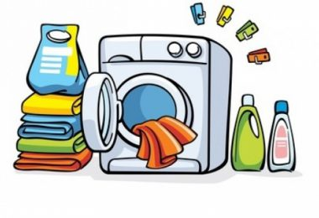  4 | INSTRUCTIONS  Ask the child to help you put the pile of dirty washing into the washing machine. Give them instructions such as:  “Find Daddy’s socks and pants”  “Find Mummy’s t-shirt and jeans”  “Find Daniel’s trousers and jumper”  “Find Mummy’s skirt and vest”  “Find Elsa’s tights and dress”

PUTTING THE WET WASHING ON THE LINE
EQUIPMENT NEEDED  - Clothes  - Washing line or tumble drier  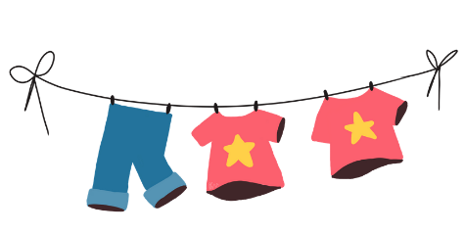  4 | INSTRUCTIONS  Ask the child to help you to put the wet washing on the washing line or in the tumble dryer. Give them instructions such as:  “Find Mummy’s socks and pants”  “Find Daddy’s t-shirt and vest”  “Find Daddy’s trousers and jumper”  “Find Mummy’s skirt and tights”  “Find Elsa’s dress and cardigan”  “Find Daniel’s shorts and coat”

HIDE AND SEEK
EQUIPMENT NEEDED  - Clothes  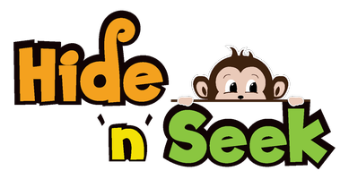  4 | INSTRUCTIONS  Play ‘Hide and Seek’ with clothes. Ask the child to hide clothes for others to find. For example:  “Hide the socks under the table”  “Hide the t-shirt on the chair”  “Hide the shoes under the chair”  “Hide the hat on the bed”

DRESSING TEDDY AND DOLLY
EQUIPMENT NEEDED  - Teddy and Teddy’s Clothes  - Dolly and Dolly’s Clothes  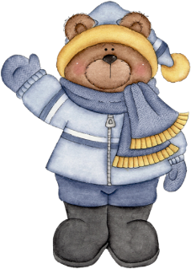  4 | INSTRUCTIONS  Put the Teddy/Dolly and his/her clothes in front of the child. Ask the child to find different clothes to put on the Teddy/Dolly.  “Find Dolly’s socks and t-shirt”  “Find Teddy’s hat and trousers”  “Find Teddy’s shoes and scarf”  “Find Dolly’s t-shirt and hat”  “Find Teddy’s dress and tights”  “Find Dolly’s coat and skirt”  “Find Teddy’s trousers and jumper”

UNDERSTANDING FOOD VOCABULARY

FEEDING TOYS/ PUPPETS
EQUIPMENT NEEDED  - Teddy  - Dolly  - 2 Blankets  - Pretend food or real food  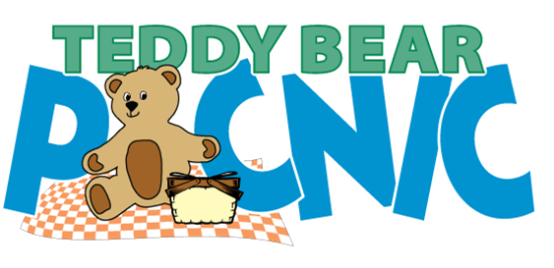 | INSTRUCTIONS  Set up a Teddy Bear’s Picnic using real food or play food (you could change the Teddy and Dolly for any favourite toys). Give the child instructions such as:  “Put the apple on Teddy’s blanket”  “Put the orange under Teddy’s blanket”  “Put the apple under Dolly’s blanket”  “Put the banana on Teddy’s blanket”  “Put the sandwich on Dolly’s blanket”  Tip: Try to use foods that the child likes to eat. This will allow them to hear the words more throughout the week.

PUTTING THE SHOPPING AWAY
EQUIPMENT NEEDED  - Food shopping  - Cupboard  - Fridge | INSTRUCTIONS  Ask the child to help you put the food shopping away. Give them instructions such as:  “Put the tomatoes and the cucumber in the fridge”  “Put the apples and the oranges in the fridge”  “Put the squash and the chocolate in the cupboard”  “Put the bananas and the bread in the cupboard”  “Put the bread and the biscuits in the fridge”  “Put the crisps and the cake in the cupboard”  “Put the grapes and the yoghurts in the fridge”  Tip: Make sure that your instructions are not predictable. For example, if you usually store biscuits in the fridge then give the instruction to put them in the cupboard.

UNDERSTANDING VEHICLE VOCABULARY

GARAGE PLAY
EQUIPMENT NEEDED  - Toy vehicles (big and little version of each)  - Toy Garage (or pretend garage made out of a cardboard box)  - Track (or pretend road/track made out of paper)  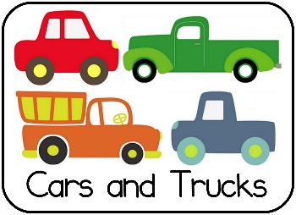 | INSTRUCTIONS  As the child is playing with the different sized toy cars, lorries, trains, buses etc. Give them some instructions such as:  “Put the big car in the garage”  “Put the little train in the garage”  “Put the little bus on the road”  “Put the big lorry in the garage”  “Put the little car on the road”

UNDERSTANDING ANIMAL VOCABULARY

SONG TIME: OLD MACDONALD
EQUIPMENT NEEDED  - Toy animals or puppets | INSTRUCTIONS  Put the toy animals or puppets on the floor. Sing the song ‘Old Macdonald Had a Farm’ with the child. As you say animals and make their sound, encourage the child to choose the correct animal/puppet.  “On that farm he had a pig, a cow and a sheep”  “On that farm he had a chicken, a goat and a horse”  “On that farm he had a duck, a dog and a donkey”

UNDERSTANDING VERB VOCABULARY

SIMON SAYS
EQUIPMENT NEEDED  - Teddy & Dolly  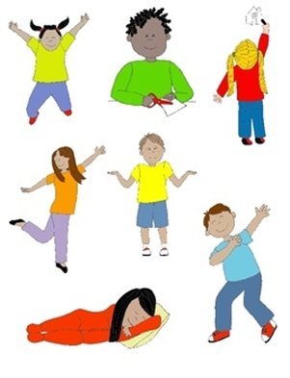 | INSTRUCTIONS  Play the game ‘Simon Says’ with the child but to make it easier use words such as ‘Mummy says’, ‘Daddy says’ or ‘Teddy says’. Give instructions such as:  “Make Teddy jump on the table”  “Make Teddy sit on the chair”  “Make Dolly lie on the chair”  “Make Teddy lie on the table”  “Make Dolly sit on the table”  When you first play the game demonstrate all of the actions to the child, but over time gradually reduce this so that the child learns what the words mean.

If you have any questions or would like further information, please do not hesitate to contact your local Therapist.

