ENCOURAGING UNDERSTANDING OF INSTRUCTIONS

FOUR INFORMATION CARRYING WORDS (KEY WORDS)
KEY POINTS

- Four-year-old children usually understand four key words in instructions. For example, “Give Mummy the big, blue shoes”; “Put the big, green apple in the fruit bowl”. For a word to be a ‘key word’ there must be a choice available e.g. ‘Mummy’, ‘daddy’; ‘big’, little ’; ‘green, ‘red’; ‘apple’, and ‘banana’.

- Before you start the activities in this pack, check that the child knows colours and can understand the words ‘big’ and ’little’; and ‘on’ and ‘under’.

- Children often understand more words than they can say.

- Play these games in everyday activities (bath time, getting dressed and mealtimes) so that the child is learning the words throughout the day.

- These games are to help the child understand words. You do not need to ask them to say the words.

- When playing these games try not to gestures or pointing. This will help the child to learn to understand the words you are using.

UNDERSTANDING BODY PARTS VOCABULARY

BATHTIME
EQUIPMENT NEEDED  - Flannel/Sponge  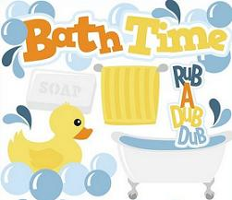  - SoapSection 4 | INSTRUCTIONS  Give the child instructions such as:  “Put soap on your arm and water on your leg”  “Put water on your leg and soap on your hand”  “Put water on your nose and soap on your head”  “Put soap on your ears and water on your toes”  “Put soap on your tummy and water on your back”  “Put water on your hair and soap on your fingers”

POORLY TEDDY
EQUIPMENT NEEDED  - Teddy  - Dolly  - Big and Little Plasters  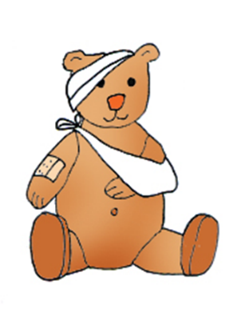 | INSTRUCTIONS  Tell the child that Teddy and Dolly have fallen over. Tell the child where to put the different plasters.  “Put a big plaster on Teddy’s eyes and ears”  “Put a little plaster on Dolly’s nose and hand”  “Put a little plaster on Dolly’s tummy and leg”  “Put a big plaster on Teddy’s arm and head”  “Put a little plaster on Dolly’s leg and face”  “Put a big plaster on Teddy’s head and back”  “Put a big plaster on Teddy’s hand and neck”

COLOURING
EQUIPMENT NEEDED  - Colouring pencils or crayons  - Two Colouring pictures e.g. Teddy/Dolly/ Different Characters (in a colouring book or printed from the internet).  4 | INSTRUCTIONS  Give instructions for colouring in the Teddy and Dolly. For example:  “Colour Teddy’s eyes and nose blue”  “Colour Teddy’s hands and feet red”  “Colour Dolly’s tummy and back orange”  “Colour Dolly’s nose and eyes pink”  “Colour Dolly’s ears and mouth red”  “Colour Dolly’s feet and hands green”  Tip: Do not stick to typical colours e.g. red mouth, but instead use a range of colours.

UNDERSTANDING CLOTHES VOCABULARY

DRESSING IN THE MORNING
EQUIPMENT NEEDED  - Clothes  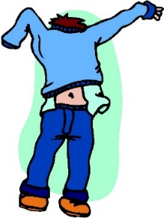  4 | INSTRUCTIONS  When you are helping the child get dressed, give them sensible and silly instructions such as:  “Find your blue pants and red socks”  “Find your green t-shirt and pink vest”  “Find your black trousers and red jumper”

DOING THE WASHING
EQUIPMENT NEEDED  - Clothes  - Washing machine  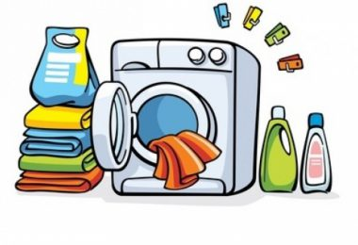  4 | INSTRUCTIONS  Ask the child to help you put the pile of dirty washing into the washing machine. Give them instructions such as:  “Find Daddy’s socks and Alfie’s* pants”  “Find Mummy’s t-shirt and Daddy’s jeans”  “Find Daniel’s* trousers and Elsa’s* jumper”  “Find Mummy’s skirt and Hannah’s vest”  “Find Elsa’s tights and Mummy’s dress”  *Replace with the name of their brother/sister

PUTTING THE WET WASHING ON THE LINE
EQUIPMENT NEEDED  - Clothes  - Washing line or tumble drier  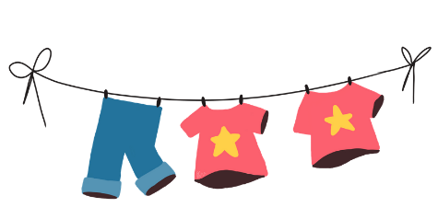  4 | INSTRUCTIONS  Ask the child to help you to put the wet washing on the washing line or in the tumble drier. Give them instructions such as:  “Find Mummy’s socks and Archie’s pants”  “Find Daddy’s t-shirt and Elsa’s vest”  “Find Daddy’s trousers and Daniel’s jumper”  “Find Mummy’s skirt and Hannah’s tights”  “Find Elsa’s dress and Mummy’s cardigan”  “Find Daniel’s shorts and Daddy’s coat”  *Replace with the name of their brother/sister

HIDE AND SEEK
EQUIPMENT NEEDED  - Clothes  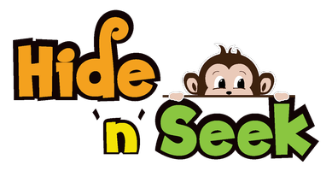  4 | INSTRUCTIONS  Play ‘Hide and Seek’ with clothes. Ask the child to hide clothes for others to find. For example:  “Hide the red socks under the table”  “Hide the blue t-shirt on the chair”  “Hide the pink shoes under the chair”  “Hide the black hat on the bed”

DRESSING TEDDY AND DOLLY
EQUIPMENT NEEDED  - Teddy and Teddy’s Clothes  - Dolly and Dolly’s Clothes  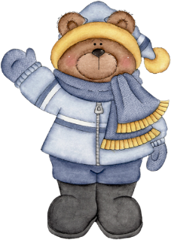  4 | INSTRUCTIONS  Place the Teddy/Dolly and his/her clothes in front of the child. Ask the child find different clothes to put on them.  “Find Dolly’s socks and Teddy’s t-shirt”  “Find Teddy’s hat and Dolly’s trousers”  “Find Teddy’s shoes and Dolly’s scarf”  “Find Dolly’s t-shirt and Teddy’s hat”  “Find Teddy’s shorts and Dolly’s trousers”  “Find Teddy’s coat and Dolly’s socks”  “Find Teddy’s trousers and Dolly’s jumper”

UNDERSTANDING FOOD VOCABULARY

FEEDING TOYS/ PUPPETS
EQUIPMENT NEEDED  - Teddy  - Dolly  - 2 Blankets  - Pretend food or real food  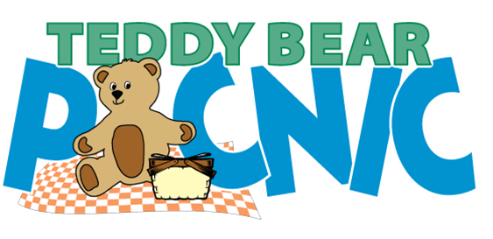 | INSTRUCTIONS  Set up a Teddy Bear’s Picnic using real food or play food (you could swap the Teddy and Dolly for any favourite toys). Give the child instructions such as:  “Put the apple and banana on Teddy’s blanket”  “Put the orange and pear under Teddy’s blanket”  “Put the apple and cake under Dolly’s blanket”  “Put the banana and grapes on Teddy’s blanket”  “Put the sandwich and biscuit on Dolly’s blanket”  “Put the sweet and drink on Dolly’s blanket”  “Put the cake and chocolate on Teddy’s blanket”  “Put the crisps and sausage under Dolly’s blanket”  Tip: Try to use foods that the child likes to eat. This will mean they will hear the words more regularly.

PUTTING THE SHOPPING AWAY
EQUIPMENT NEEDED  - Food shopping  - Cupboard  - Fridge | INSTRUCTIONS  Ask the child to help you put the food shopping away. Give them instructions such as:  “Put the tomatoes on the worktop and the cucumber in the fridge”  “Put the apples in the fruit bowl and the oranges in the fridge”  “Put the squash in the cupboard and the chocolate in the fridge”  “Put the bananas on the worktop and the bread in the cupboard”  “Put the bread on the worktop and the biscuits in the fridge”  Make sure that the child cannot guess your instructions e.g. If you usually store biscuits in the fridge then give the instruction to put them in the cupboard.

UNDERSTANDING VEHICLE VOCABULARY

GARAGE PLAY
EQUIPMENT NEEDED  - Toy vehicles (big and little version of each)  - Toy Garage (or pretend garage made out of a cardboard box)  - Track (or pretend road/track made out of paper)  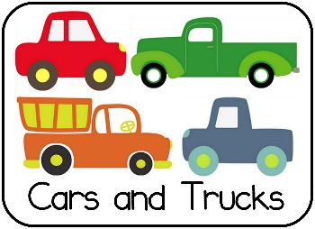 | INSTRUCTIONS  As the child is playing with the different sized toy cars, lorries, trains, buses etc. Give them some instructions such as:  “Put the car in the garage and the train on the road”  “Put the train in the garage and the tractor on the road”  “Put the bus on the road and the truck in the garage”  “Put the car on the road and train in the garage”  “Put the train on the road and the tractor in the garage”

UNDERSTANDING ANIMAL VOCABULARY

SONG TIME: OLD MACDONALD
EQUIPMENT NEEDED  - Toy animals or puppets | INSTRUCTIONS  Place the toy animals/puppets on the floor. Sing the song ‘Old Macdonald Had a Farm’ with the child. As you name each animal and make the sound, ask the child to choose the appropriate animal/puppet.  “On that farm he had a big pig, and a little cow”  “On that farm he had a little chicken, and a little horse”  “On that farm he had a big duck, and a little dog”

UNDERSTANDING VERB VOCABULARY

SIMON SAYS
EQUIPMENT NEEDED  - Teddy & Dolly plus one other toy  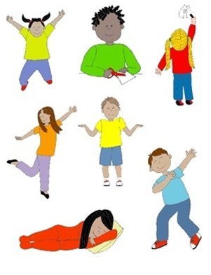 | INSTRUCTIONS  Play the game ‘Simon Says’ but use words such as ‘Mummy says’, ‘Daddy says’ or ‘Teddy says’. Give instructions such as:  “Make Teddy jump and Dolly sit”  “Make Teddy sit and Buzz jump”  “Make Dolly lie down and Peppa sit”  “Make Teddy jump and Woody run”  “Make Dolly sit and Jesse lie down”  When you first play the game show the child the different actions, but over time gradually reduce this so that the child learns what the words mean.
If you have any questions or would like further information, please do not hesitate to contact your local Therapist.

