IDEAS FOR WORKING ON PRONOUNS

Ideas for helping a child to develop their language

What is a Pronoun?
- Pronouns are words such as: ‘he’, ‘she’, ‘him’, ‘her’, ‘they’ and them’, words that we use to refer to different people.
- Before the child can understand pronouns, they need to be able to recognise boy/girl/man/woman.
- The child needs to work on understanding pronouns before they work on using pronouns.

Understanding Pronouns

Activity 1 - Dressing Boy/Girl
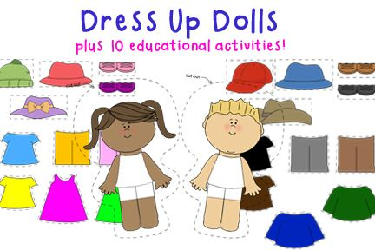
Either have boy and girl dollies, use shop bought boy/girl puzzles or print pictures of a boy and girl with their clothes from the internet.
Place the boy and girl with their clothes on the table. Pick up a piece of clothing and give the child instructions such as:
“He is wearing socks”
“She is wearing a t-shirt”
“She is wearing a hat”
“He is wearing a jumper”
Encourage the child to put the item of clothing on the appropriate doll/picture.
Make sure that there is not a pattern to when you are using ‘he’ and ‘she’ and try to give the child unexpected instructions such as “He is wearing tights” so that the instructions are not predictable.

Activity 2 – Hide and Seek with pictures
Use the pairs of action pictures provided to play ‘Hide and Seek’. Hide the pictures around the room and give the child instructions such as:
“Find he is running”
“Find she is dancing”
“Find she is sleeping”
“Find he is jumping”
“Find she is crying”

Encourage the child to go and look for the picture you asked for. If they make a mistake describe the picture that they have brought to you and then say “I asked for…” and repeat the instruction.

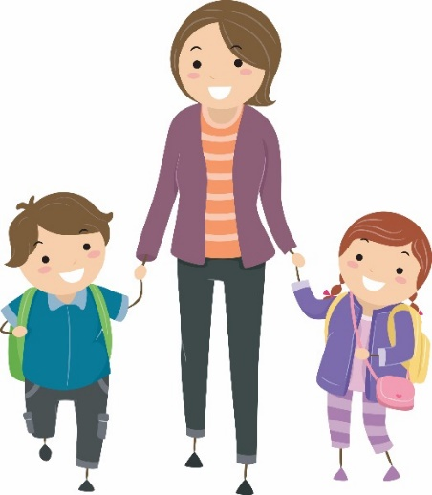
Activity 3 – Modelling Pronouns in Everyday life
As you go about your daily lives describe what people around you are doing so that the child can link the pronoun with boy/girl/man/woman. At this stage it is important that you don’t ask the child to copy.
For example:
“Look he is running”
“Look she is laughing”
“Look he is hopping”
“Look she is crying”
“Look she is walking”
“Look he is kicking the ball”
“Look he is riding a bike”

Using Pronouns

Once the child understands the difference between ‘he’ and ‘she’ you can move on to helping them to use these words.
Activity 1 – Dominoes
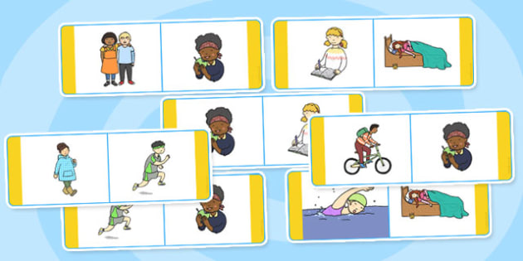
Play Dominoes using the action pictures provided. As each player matches up their domino encourage them to describe the action picture using the words he/she.
For example:
He is running
She is walking
He is riding a bike
She is eating an apple

If the child makes a mistake say them “Is it he is…or she is…?”
Activity 2 – Matching Pairs

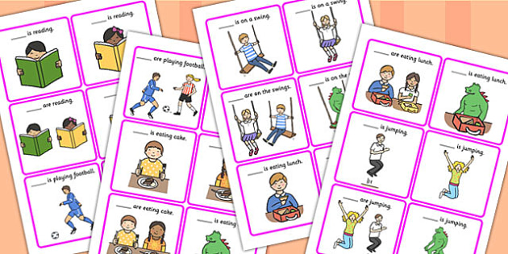
Place the pairs of action pictures provided face down on the table. Take turns to pick up two pictures and describe them using the words ‘he’ and ‘she’.
For example:
“He is reading”
“He is on the swing”
“She is jumping”
The winner is the person who finds the most pairs.
If the child makes a mistake say them “Is it he is…or she is…?”.

Activity 3 – Snap
Shuffle the pairs of action pictures provided and divide them between the players. Take turns to place a picture on the pile and describe it using the pronouns ‘he’ and ‘she’. For example:
“He is reading”
“He is writing”
“She is drawing”
“He is painting”
“He is running”
If the player sees a matching pair then they should shout “snap” and take all of the pictures from the pile. The winner is the player who has the most pictures at the end of the game.
If the child makes a mistake say them “Is it he is…or she is…?”

Activity 4 – Observation Walk
Take the child on a walk. Point out people for them to describe and ask them what they are doing. For example:
“He is reading”
“He is writing”
“She is drawing”
“He is painting”
“He is running”
“She is laughing”

If the child makes a mistake say them “Is it he is…or she is…?”

