UNDERSTANDING QUESTION WORDS

Target:

The child will develop his/her understanding of the question words: who / where / what / what like / what happened / when

You will need:

- sets of your own pictures representing the answers to the different ‘wh’ questions (see next page for ideas).
- Colourful semantics question symbols (provided on next page ).

What to do:

Take two sets of pictures e.g. the ‘who’ and the ‘where’ set.
- Place the ‘colourful semantics’ symbols for those sets (in this case the ‘who’ and ‘where’ set) on the table where you can both see them.
- Mix the sets of pictures together and take it in turns to choose one of the pictures.
- Look at the picture together and decide which of the two categories it belongs to. You can talk about the pictures using the question words and try to link this to the type of picture e.g. “Who is this? Oh this is a picture of Grandma. She’s a person. This must go with the ‘who’ pictures”.
“Where is this? This looks like a lovely place to visit. This must go with the where pictures”.
Continue until all the pictures have been sorted onto the question symbols.
- When the child can sort ‘who’ and ‘where’ pictures consistently with little help from you, you could then add the ‘what’ category so that you are sorting three sets of pictures. When the child can sort three sets of pictures add the next one etc. until they are able to sort all the sets.

Question word | Examples |  | Makaton symbol |  | Makaton sign
Who? | Pictures of favourite characters, school friends, family members
What? | Pictures of toys or objects at home / school; pictures from catalogues or magazines
Doing? | Pictures of people doing things (you could take these yourself, find on the internet or look in magazines)
Where | Rooms in the house/school; places near where you live; holiday photos  Habitats (beach/ forest/polar etc)  Preposition pictures e.g. in /on/under the box / bed etc. |  | 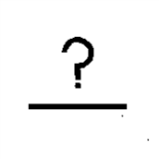 |  | 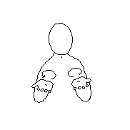
When? | Pictures of times of the day (e.g. from visual timetable or photos of dinnertime, bedtime etc.)  Pictures representing seasons, special events e.g. birthday, Christmas etc.
What like? | Pictures / symbols / samples of fabric representing different adjectives e.g. different colours / textures / sizes etc. | What like?  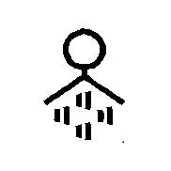  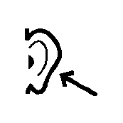 |  | Feel?  Feel (texture)?  See?  Hear?  Smell?

