

**WELCOME TO OUR WINTER NEWSLETTER**



In this issue we are thinking about :







* Flu Jabs
* Restore2 Mini
* Save the Date: Friday 16th June 2023, for the Big Health Day at Oxstalls Sports Park, Gloucester



The Health Action Group is for people with learning disabilities and/or autism, their parents/carers and lots of health care professionals.

These are just some of the health topics being talked about this year by the Health Action Group.

We aim to work together to make health care better

**Flu Jabs**

**Flu** isn’t just a heavy cold. It spreads quickly and symptoms come on very quickly.

**Colds** are much less serious and start slowly with a stuffy or runny nose and a sore throat.

Signs of flu are: -

* Fever
* Chills
* Headache
* Aches and pains in the joints and muscles
* Very tired



**The best way to stop getting flu is by having the flu jab before the flu season starts**.

Flu can affect anyone. People with a learning disability (and people with other long-term health conditions) are more likely to have problems from flu.

The flu vaccine protects you, your family and the people who care for you.



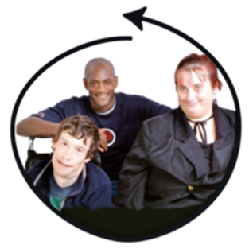

A Personal Assistant (PA) is someone who is paid to help people with care and support needs. The NHS provide a free flu vaccination to PAs.

Information Source: [The flu vaccination: who should have it and why - GOV.UK (www.gov.uk)](https://www.gov.uk/government/publications/flu-vaccination-who-should-have-it-this-winter-and-why/the-flu-vaccination-who-should-have-it-and-why)

 [Flu vaccination guidance for personal assistants (PAs) (publishing.service.gov.uk)](https://assets.publishing.service.gov.uk/government/uploads/system/uploads/attachment_data/file/1108133/UKHSA-12463-flu-immunisation-guidance-personal-care-assistants.pdf)****

**Click on this link to follow the story of Brian as he goes for his flu vaccination:** [Protect yourself from flu, have the flu vaccine (publishing.service.gov.uk)](https://assets.publishing.service.gov.uk/government/uploads/system/uploads/attachment_data/file/1102054/UKHSA_12388_flu_easy_read_leaflet_winter_2022.pdf) 



RESTORE2 mini

-

RESTORE stands for:-

**R**ecognise **E**arly **S**oft Signs, **T**ake **O**bservations, **R**espond, **E**scalate.

When a person cannot tell us when they are feeling poorly, **RESTORE2** **mini** can help to spot early signs that someone’s health is getting worse.

**RESTORE2 mini** is a form to help care staff, carers, family members and paid support staff to look at the ‘soft signs’ that someone’s health is getting worse.

**RESTORE2 mini** gives a way to tell health care professionals when you sense someone you care for is ‘just not themselves’.

Gloucestershire **RESTORE2 mini** project group have made a training film.

Click on this link to watch the film on YouTube

* <https://youtu.be/SOOJjF8bCmY>

Gloucestershire Restore 2 Mini project group have developed a training film for staff working in residential care homes and domiciliary care. The film will also be useful for unpaid/family carers.

Clink on this link to watch the YouTube training film:-

[https://youtu.be/SOOJjF8bCmY](https://eur01.safelinks.protection.outlook.com/?url=https%3A%2F%2Fyoutu.be%2FSOOJjF8bCmY&data=05%7C01%7CSimon.Shorrick%40ghc.nhs.uk%7C127ac9e6506b452f9ce408dabd989439%7Cf8120e622f9442d0beb68143b2f833fb%7C1%7C0%7C638030760613784098%7CUnknown%7CTWFpbGZsb3d8eyJWIjoiMC4wLjAwMDAiLCJQIjoiV2luMzIiLCJBTiI6Ik1haWwiLCJXVCI6Mn0%3D%7C3000%7C%7C%7C&sdata=mlbsPESpfOjaGA1uAc86RaYwdBfvHC9scoU0tQ64ht0%3D&reserved=0) 





A change in soft signs might be:-

* A change in the way someone behaves
* Weeing less
* Being more sleepy
* Feeling or looking ill
* Moving less
* Saying no to food and drink







If you like our  film give it a thumbs up or share the link

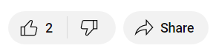 



|  |  |
| --- | --- |
| 15th Anniversary  Save the Date! | |
|  | Date: Friday 16th June 2023  Time: 9.30am to 3.00pm  Place: Oxstalls Sports Centre, Plock Court, Tewkesbury Road, Gloucester, GL2 9DW |
|  | The event is aimed at helping people with learning disabilities, physical disabilities, sensory impairments, autistic people and anyone with mental health support needs to stay active and healthy. |
|  | There will be lots of inclusive sports for people to try:- bikes and trikes, Powerchair football, golf, snooker, sailing, boccia, and tennis. There will also be arts and crafts, dance / drama for visitors to enjoy. |
|  | Simon Shorrick is the Lead Co-ordinator. He said "we hope this event is making a difference to people’s quality of life, as well as reducing health inequalities” |
|  | More than 1,500 people attended the last Big Health Day.  Our colleagues at Inclusion Gloucestershire made a short film which captured the spirit of the last event.  [https://youtu.be/c7-PshHvjgg](https://eur01.safelinks.protection.outlook.com/?url=https%3A%2F%2Fyoutu.be%2Fc7-PshHvjgg&data=05%7C01%7CKarin.Parker%40ghc.nhs.uk%7Cf73967ed0ef449d8c05e08da64cc46d0%7Cf8120e622f9442d0beb68143b2f833fb%7C1%7C0%7C637933125767835119%7CUnknown%7CTWFpbGZsb3d8eyJWIjoiMC4wLjAwMDAiLCJQIjoiV2luMzIiLCJBTiI6Ik1haWwiLCJXVCI6Mn0%3D%7C3000%7C%7C%7C&sdata=iT1McvqLCgnDX938lm1nDtT6I%2BrVGlXqfEQgKs%2FToHU%3D&reserved=0) Cursor |

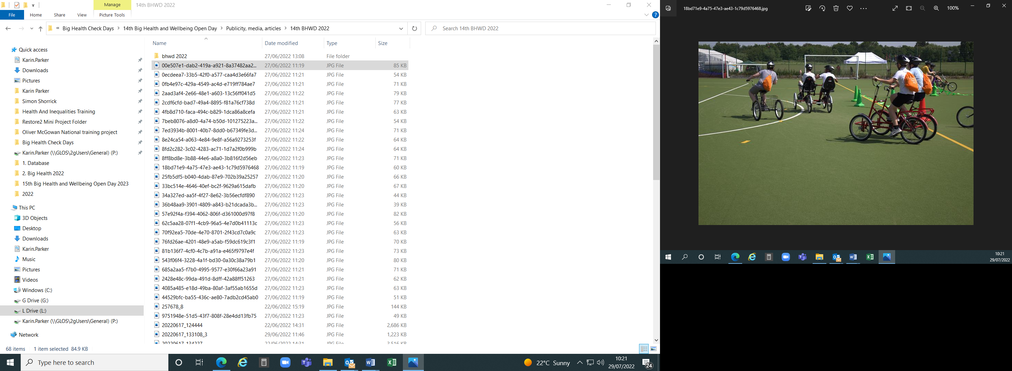 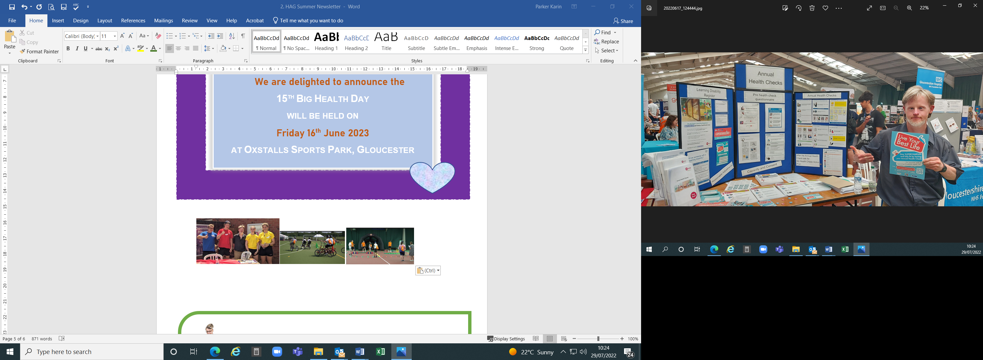 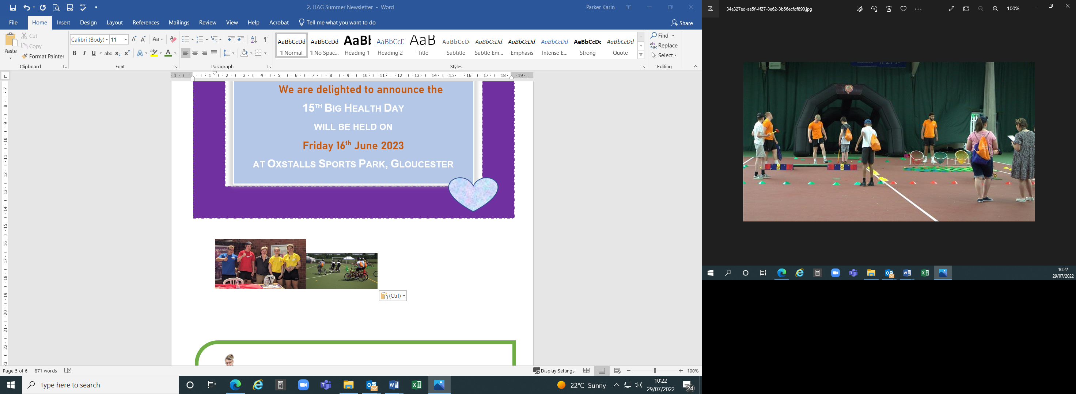

|  |  |
| --- | --- |
|  | LeDeR  Easy Read Health Information |
|  | Our colleagues who work on the LeDeR programme have developed some NEW Easy Read resources. They can be downloaded from Inclusion Gloucestershire LeDeR webpage.  <https://www.inclusiongloucestershire.co.uk/engagement/leder/> |
|  | * The LeDeR programme in Gloucestershire: <https://bit.ly/3lDlaEp> * Aspiration Pneumonia: <https://bit.ly/3wDM1Fu> * Accessing Healthcare in the Community: <https://bit.ly/3wELDHU>   Internet Cursor |

Did you know about the Choice and Medication website?

It’s a website which offers printable leaflets about medication in extra large size and foreign language translations.

* The leaflets are for medication used for mental health conditions.
* The leaflets are for individuals, their family and carers.
* They do not replace the manufacturers leaflets in the medication box.





 <https://www.dpt.nhs.uk/resources/medicines-in-mental-health/choice-and-medication> 

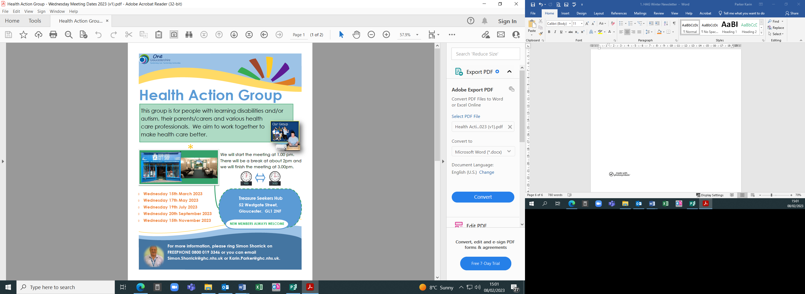

**THANK YOU** **to our colleagues at Inclusion Gloucestershire. They helped us to review and edit our Easy Read Newsletter.**

**NEWSLETTER CONTACTS** [**Simon.Shorrick@ghc.nhs.uk**](mailto:Simon.Shorrick@ghc.nhs.uk) **and** [**Karin.Parker@ghc.nhs.uk**](mailto:Karin.Parker@ghc.nhs.uk)

**Gloucestershire Health and Care NHS Foundation Trust**

**Learning Disability Health Facilitation Team**





**FREEPONE Tel. No.**

**0800 019 3346**