Volunteer Role Description

Role title | HOMEMAKER – meal time assistant
Where | Stonebow Unit Patient Dining Room – Hereford
When | 2 hrs period 11.30am until 13.30
Commitment | Monday to Sunday 1-2 sessions per week
Accountable to | Alison Hartless
What we do | ²gether NHS Foundation Trust (²gether) provides specialist mental health and learning disability services to the people of Gloucestershire and Herefordshire.  Our priority is to deliver quality services and exceptional customer experience. Our purpose is to make life better.  Our core values are as follows:  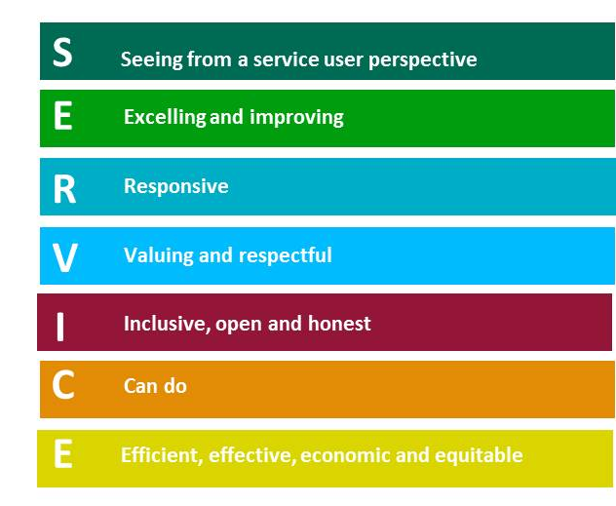  We expect our staff and volunteers to share these values in order to create the best service possible.

Why we want you | Stonebow Unit in Hereford is our Inpatient Services.  Stonebow Unit is based in Hereford city centre and consists of three inpatient wards and an acute day unit.  To support and engage with our patients during meal times.  Helping patients to have a positive eating experience in the patient dining room and assisting by replenishing the tables, helping with carrying meals from the servery.  Offer reassurance and engage with conversation where appropriate.  To work alongside the Catering team and Ward staff in a volunteer role.
Role tasks | Under the guidance of the catering/ nursing team:-  - Preparing dining tables for meal service at times with patient involvement.  - To support meal times by assisting with carrying trays, providing drinks and responding to patient’s requests.  - Offer reassurance and engage in conversation as appropriate  - Report any observations to the catering team that may need to be recorded by the Nursing Team.
Skills and attributes you will need | - Interest in working with people within Mental Health  - Ability to communicate with a range of people with diverse needs  - Patience  - Compassion  - Empathy  - Ability to follow direction
Most challenging part of the role | Some behaviours of our patients may be challenging for others to make sense of, and you may have difficulty with communicating with patients at times.
Training required and how often this will need to be completed | - Corporate Induction – day 1  - Safeguarding – once only – will be completed on day 1 of Corporate Induction  - Breakaway Training – annually  - E learning Food Safety - annually  - E learning Fire Safety – every 2 years  - E learning Inflection Control – every 3 years  - E learning Manual Handling – every 2 years  - E learning Information Governance – annually
How the Trust will support you | - Relevant training to support volunteer role  - Local induction

