My End of Life Plan

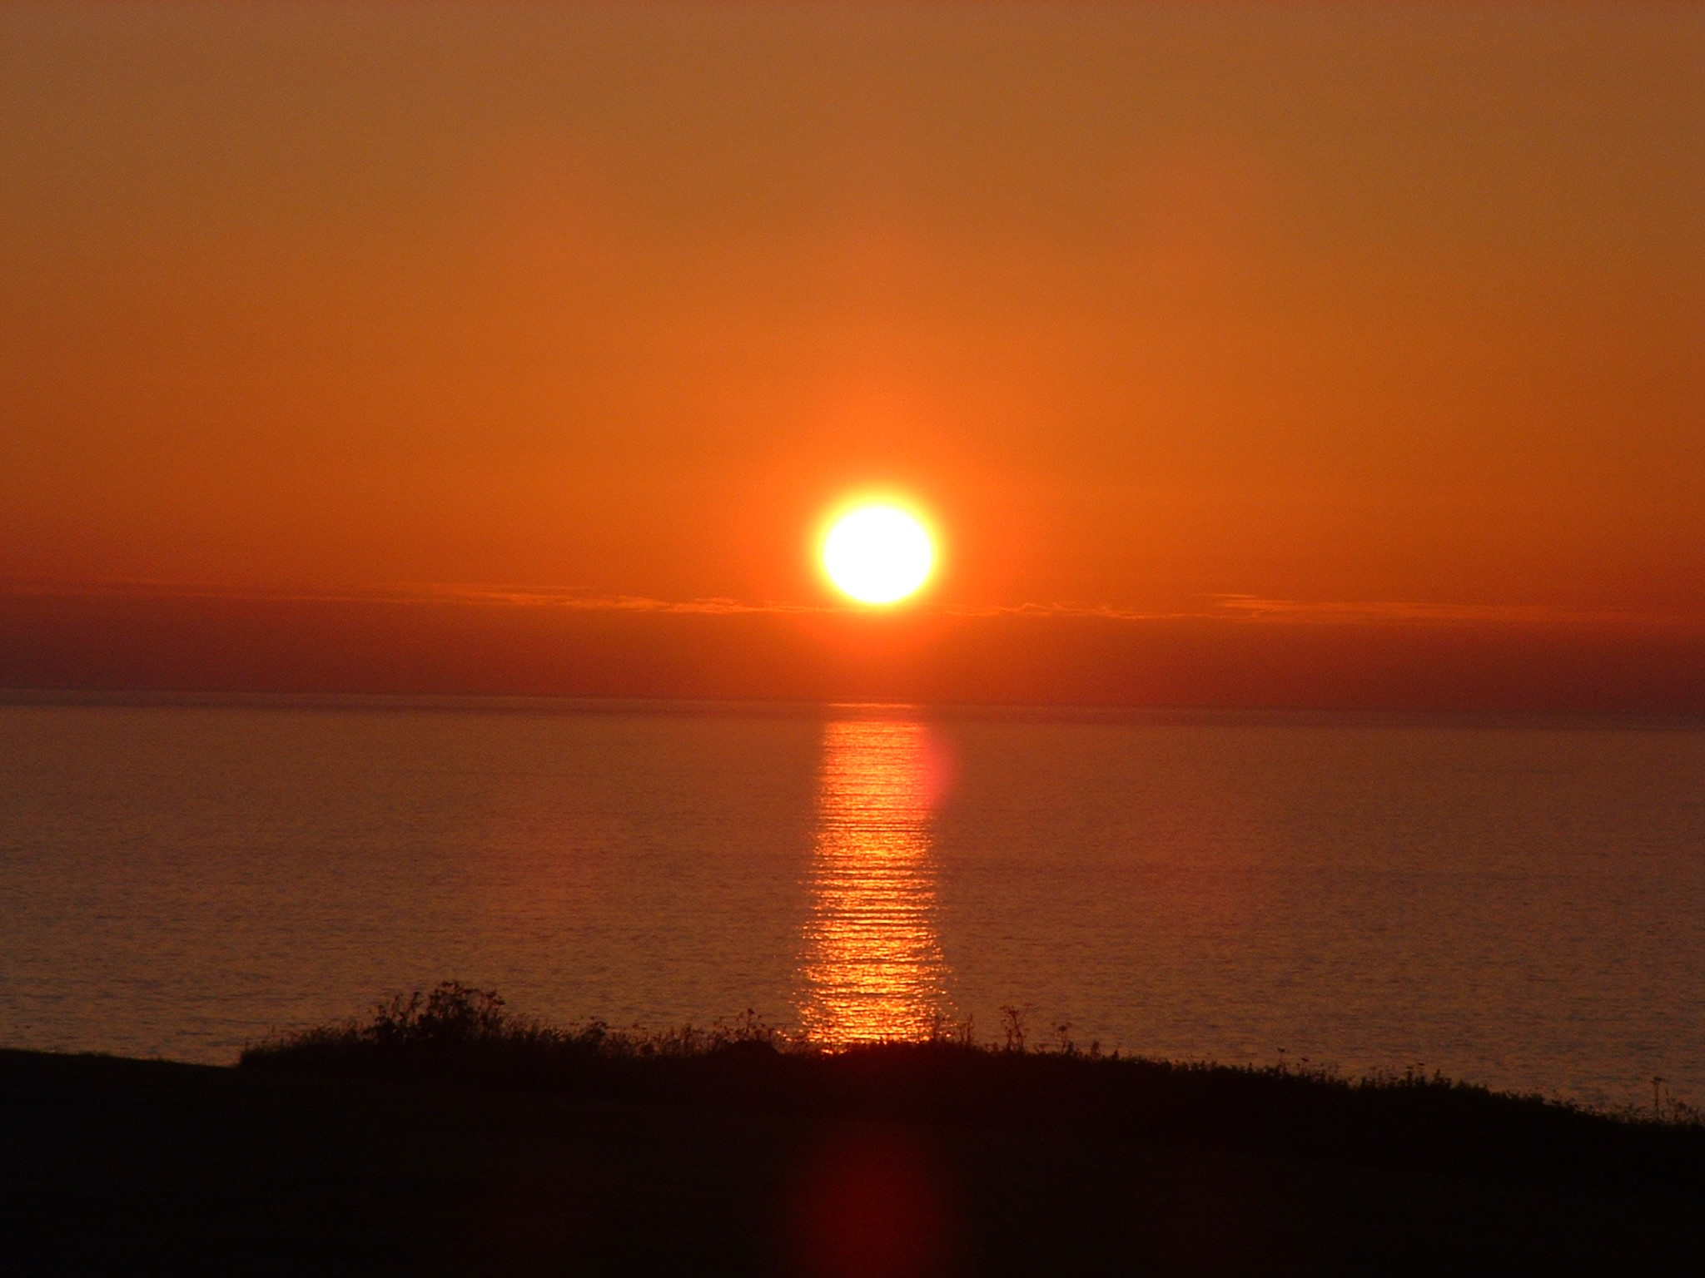

Photo of me
What I want to happen

Photo of me

This is me.

This is my address ………………………………….……….
…………………………………………………………………………………………………………………………………………
This is where I live, my home.

My Home

I want to make a Will:


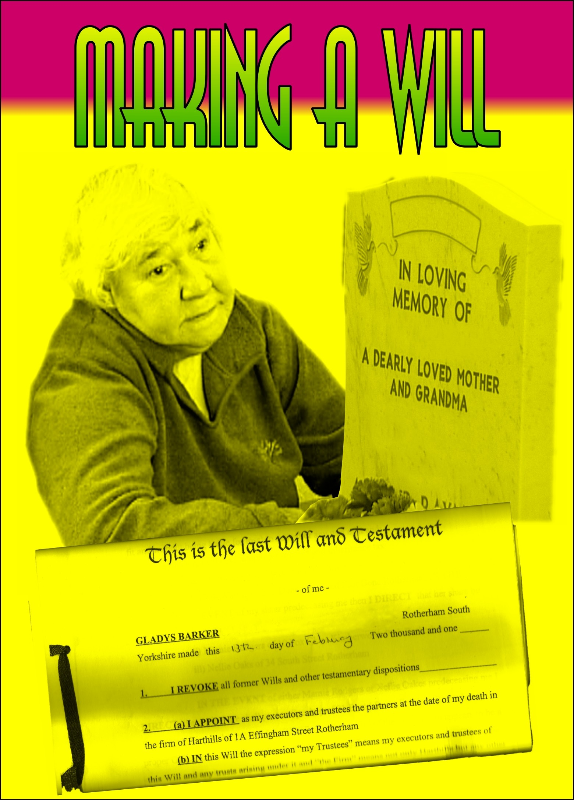

Yes



No

This is my next of kin:

Photo
Name: ………….………....…….....

Address: ...……………..………….…………………………………………………………..
…………………………………………..

Tel: ……………….……………….……

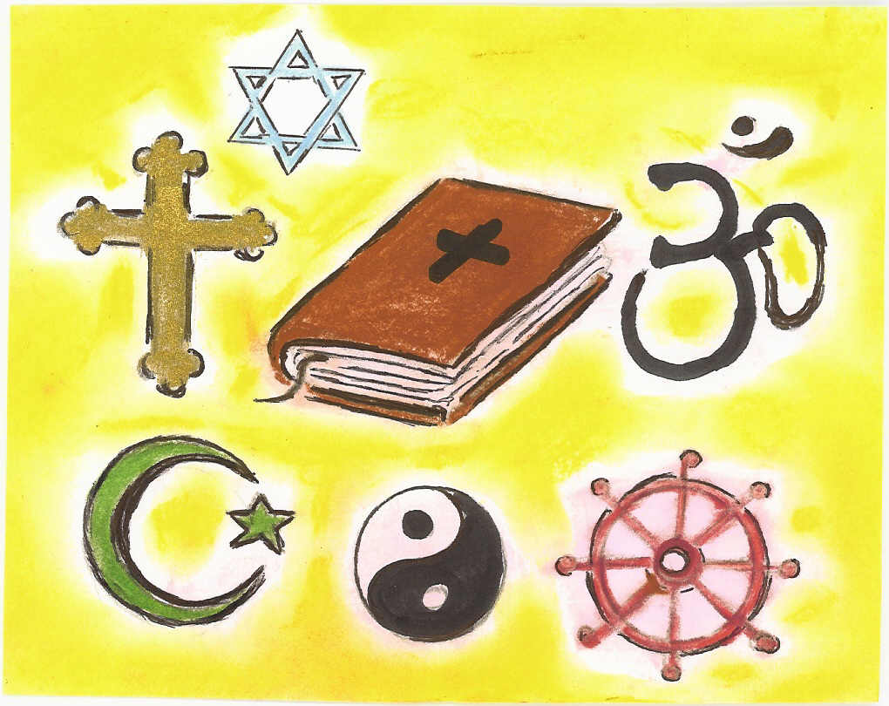

This is my religion:
…………………………………………

These people are important to me:

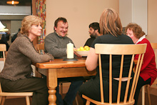

………………..……
………………..……
………………..……
………………..……
………………..……

These people are important to me:

………………..……
………………..……
………………..……
………………..……
………………..……

If I get very poorly, and I’m not going to get better, this is where I want to be when I die:
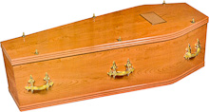

…………………………………………

Picture of actual home

My Home.

Picture of hospital

In hospital.

Picture of hospice

In a hospice.

Picture of
me

These things belong to me. They are important to me:

………………..……
………………..……
………………..……

………………..……
………………..……
………………..……

Picture of
me

These things belong to me. They are important to me:

………………..……
………………..……
………………..……

………………..……
………………..……
………………..……

Picture of
me
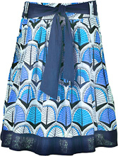
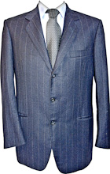
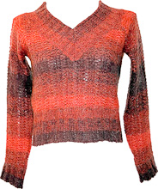

When I die, this is where I want my belongings to go:
…………………………………………………………..……

………………………………………………………………..

………………………………………………………………..

………………………………………………………………..

………………………………………………………………..

………………………………………………………………..

I want to be buried:

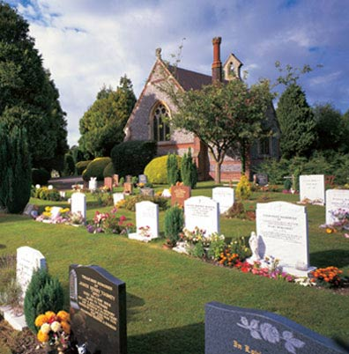

Yes

No

This is where I want my coffin to be buried:

………………..………………………………….

This is how I want my grave to be marked:

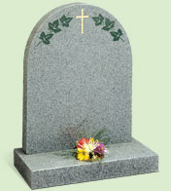

……………………………………………………

……………………………………………………

……………………………………………………

……………………………………………………

I want to be cremated:

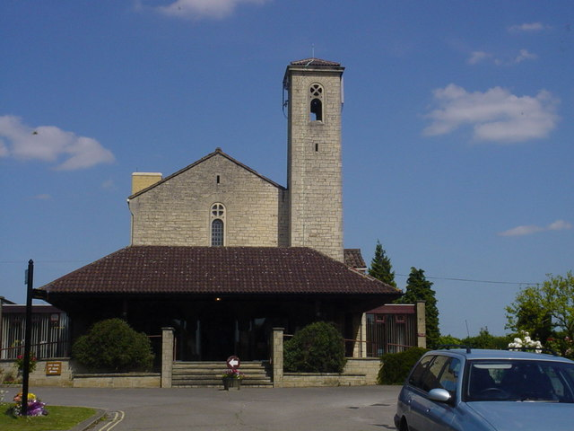
Yes

No

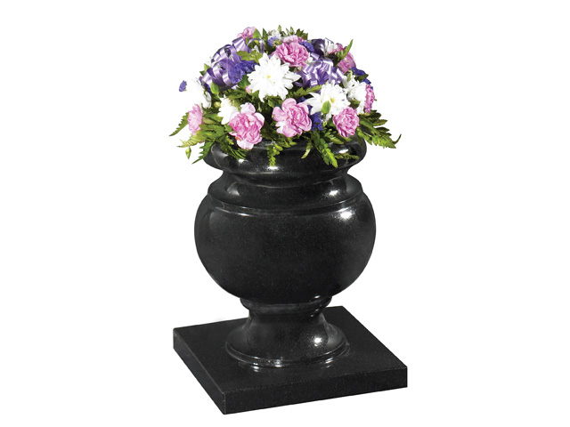
I want my ashes to be:

……………………………………………………

……………………………………………………

……………………………………………………

……………………………………………………

I want a plaque to show where my ashes are:

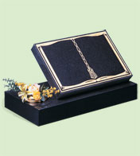

Yes

No

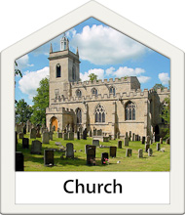
I want my funeral service to take place here:

………………..……….……………………………..….

My favourite colours are:



………………..……….………………………………….

I want flowers at my funeral.

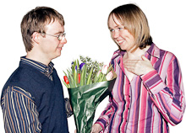

My favourite flowers are:

………………..……….……………………….…..….

Has anyone commented that you might have a hearing problem?

Yes No

Advice:

I don’t want flowers at my funeral. I want people to give money to my favourite charity:

………………..……….………………
………..……………………………….
………………………………………...

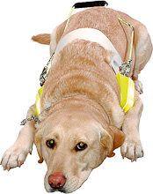
Yes

No

My funeral service.

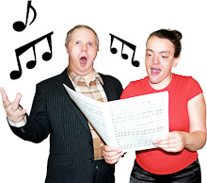
These are my favourite songs, hymns, records, music and prayers .…………….………..
…………………………………………….
…………………………………………….
…………………………………………….
……………….…………………………….

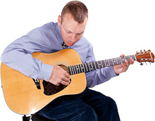

I want these things to happen at my funeral service:

…………………………………………………………………….
…………………………………………………………………….
…………………………………………………………………….
…………………………………………………………………….
…………………………………………………………………….
…………………………………………………………………….

Picture of
me

Picture of
me
These are things you need to know about my choices and my wishes:

…………………………………………………………………….
…………………………………………………………………….
…………………………………………………………………….
…………………………………………………………………….
…………………………………………………………………….
…………………………………………………………………….

My Family – their wishes:

…………………………………………………………………….
…………………………………………………………………….
…………………………………………………………………….
…………………………………………………………………….
…………………………………………………………………….
…………………………………………………………………….

After my funeral service I want:

…………………………………………………………………………………………………..
…………………………………………………………………………………………………..
…………………………………………………………………………………………………..

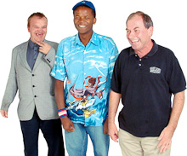



Tea and Coffee
Families and Friends

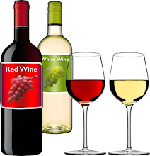
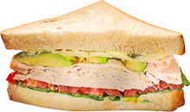
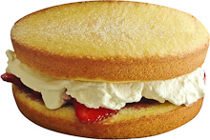
Cakes
Sandwichess
Wine

These people helped me make my ‘End of Life Plan’:

Photo of me

………………..……
………………..……
………………..……

………………..……
………………..……
………………..……

I have given my consent to make this book:

…………………………………..

Yes

No

………………………………….

Acknowledgements:

Name | Involvement | Organisation
Julie Crisp  Cathy Jones  Gill Frances  Cath Hayes  Enfys Groombridge | Participants of former NVQ End of Life Project | Brandon Trust
Lorraine Peters  Simon Shorrick | Editing | Health Facilitation Team  ²gether NHS Foundation Trust
Photosymbols | Images | www.photosymbols.com
Calderstone NHS Trust | ‘When I die’ booklet | Calderstones NHS Trust
Memorials of Distinction | Photos | www.memorialsofdistinction.co.uk
Lion Hudson plc | Image | Lion Hudson plc
Speak up Self Advocacy | Image | www.speakup.org.uk
Belinda Hope | Drawings | Artist
HAG Group  (Health Action Group) | Review and influence health related targets and projects | Working Project Group to the Learning Disability Partnership Board
4 Me About Me Group | Review My End of Life Plan | ²gether NHS Foundation Trust Sub Group to the Communications and Publications Group

Originator: Julie Crisp, Brandon Trust
© 2017 ²gether NHS Foundation Trust.
Not to be reproduced in whole or in part without the permission of the copyright holder.
Health Facilitation Team
Learning Disability Services
²gether NHS Foundation Trust
Freephone: 0800 019 3346

www.2gether.nhs.uk

