GHC Trust 5 Year Strategy

The Trust Strategy is our plan for the next five years.

It says what we aim to achieve.

It describes how we are going to do it.

We listened to staff, people who use our services, and organisations.

They told us what was important to them.

 | The plan must be about the things that matter to people.
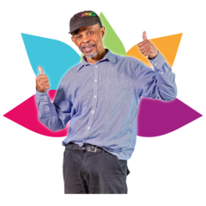 | We have written a statement to say what we are here to do. This is called a “mission statement”.  Our mission is:  “Enabling people to live the best life they can”

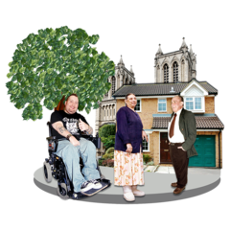 | We have written a statement to describe our goal. This is called a “vision statement”.  Our vision is:  “Working together to provide outstanding care”
Our strategy describes four aims. These aims will guide our work. They will help us reach our goal.

Our four aims are
- High Quality Care
- Better Health
- Great Place to Work
- Sustainability

- High quality care

This is how we will know if we deliver high quality care:

- The people who use our services and their carers tell us that they are happy with their care

- Those who use our services and their carers feel like their views are heard.

- We will work with people who use our services and their carers to find out what makes good care

- We achieve an overall Care Quality Commission rating of ‘Outstanding’

- Better health

We want to improve people’s health.

We will do this by working with our communities to improve health outcomes.

- Great place to work

We want to create a culture where staff feel that they are listened to, valued and involved by the Trust.

A happy workforce will help us achieve high quality of care.

- Sustainability

We want to do our bit to look after our community and planet.

One way we will do this is by reducing our total carbon footprint.

Carbon footprint is the amount of carbon dioxide released into the atmosphere as a result of the activities of a particular individual, organisation, or community.

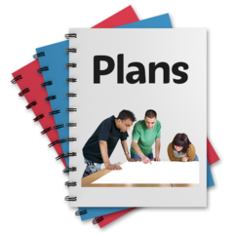 | We will deliver our strategy through our Enabling Strategies which are a set of smaller plans which will focus on delivering our four aims.
This Easy Read version has been produced with our For Me, About Me group made up of Experts by Experience.

