REPEATING AND EXTENDING

STRATEGIES AND ACTIVITIES TO TRY AT HOME

HOW IT HELPS
When your child say a word or phrase for the first time, they are not likely to say it correctly. For example, they may try to say “Daddy read a book” but they say “Daddy book”. Repeating the word or phrase after the child and filling in new or missing words lets them know that you have understood them and shows how the words fit into a bigger phrase.
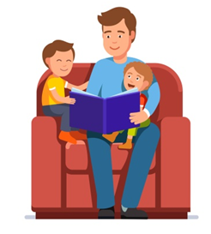
TOP TIPS
- Repeat what your child has said and add a word or two.
- If your child usually says one word at a time, try saying two words back.
- Choose the words that are most relevant to the situation, for example, if you child says ‘more’ you might say ‘more milk’ or ‘more biscuits’, depending on what they want more of.
- Do NOT ask your child to copy the extra words- hearing the words is enough to help them learn.

HOW TO REPEAT AND EXTEND
Your child says… | What you could say…
“messy” | “messy table”
“Daddy go” | “Daddy’s going to work”
“dog” | “dog is running”
