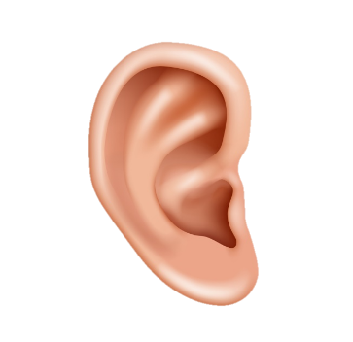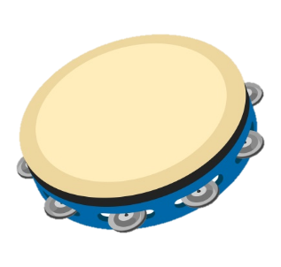

**WHAT IS PHONOLOGICAL AWARENESS AND WHY IS IT IMPORTANT?**

* Phonological awareness is knowing that what we say is made up of sounds, syllables and words and being able to manipulate these.
* Children with speech sound difficulties can often have difficulties with phonological awareness and working on these will be important to help them change how they say words.
* Phonological awareness is also an important underpinning skill for later reading and writing development.

**PHONOLOGICAL AWARENESS ACTIVITIES**

Below are some activities that you can easily do with your child at home.

Remember these are listening tasks and do not require your child to say words correctly.

If your child says a word incorrectly, just repeat back what they have said and fill in the correct sounds e.g. Child: “look dun!” You: “yes the sun!”

**ENVIRONMENTAL NOISES**

**Listening walk** Go on a walk together and see what you can hear. Exaggerate listening by cupping your ear or making some big ears to stick on your hat. Point out familiar noises to your child and copy them- *beep beep, vrrmmm, tick tock, woof woof*- and encourage your child to point to the source of the sound.

**What’s that noise?** Find pairs of everyday objects that make noise – *keys, crisp packet, a water bottle-* and explore these with your child to see what noises they make. Share the objects amongst you and your child so you have one of each. Put a big book up between you and no peeking! Make a noise with one of the objects and see if your child can find their object that makes the same noise. It’s okay if they don’t get it first time, encourage them to listen again! This game could also be done with animals.

**Who said that?** Make a lotto board by drawing pictures of familiar animals for each child. The adult should make the animal noise and the child has to find the animal it matches. They can cover the picture with a penny or counter. See who can cover all of their animals first!

**Musical instruments** Find some musical instruments or make some (use rice in bottles and Tupperware, pans and spoons for drums. Get your child to shut their eyes while you make a noise with one of the instruments. When they open their eyes, see if they can find the instrument and make the noise. You can make this harder by getting your child to listen for a sequence of two sounds.

SOUND AWARENESS ACTIVITIES

# PHONOLOGICAL AWARENESS

**RHYME**

**Stories and rhymes** Choose familiar stories or songs that have lots of rhymes. Sing or read these with your child, emphasising the words that rhyme and don’t forget to pause for them to fill in the gaps “humpty dumpty had a great…?” You can mix this up by reading or singing the songs with the wrong rhyming words to see if your child notices and can help fill in the right one!

**Rhyme hunt** Choose an easy rhyming word e.g. *mat.* Hunt the house for things that rhyme. Help your child to try different words “does dog rhyme with mat? No- dog ends in “og” and mat ends in “at”. Dog, Mat. They don’t rhyme” “Does hat rhyme with mat? Yes hat ends in ‘at’ and mat ends in ‘at’ Hat-Mat”

**Rhyming pegs** Draw, cut out or print three pictures- two that rhyme and one that doesn’t. Help your child to work out which two rhyme and put pegs on each of them.

**SYLLABLES**

You will first need to introduce the idea that words can broken up into claps and show the child how this is done. For example: car= one clap; li-on= two claps; di-no-saur= three claps; he-li-cop-ter= four claps. Clapping names of family members can be a good way to start. Help your child by showing them how to say the word with claps. You can put your hands over theirs to help.

**Syllable clapping** Find objects from around the house and put them in a bag. Get your child to choose one of them and then together clap out the syllables/ number of beats in the word. **Dinosaur stomps** Draw some dinosaur footprints to place on the ground. Tell your child you’re going to see how many stomps a word has. Pick a word or choose any object from the bag, saying each syllable as you stand on a footprint e.g. elephant= three footprints. You can always get your child to use their dinosaur to jump to each footprint as they say the syllable.

**SOUNDS IN WORDS**

**Collect the stars** Get your child to draw and colour in some stars. Find objects around the house beginning with the same sound e.g. ‘s’ and stick a star on each of them. Set a timer and get your child to find as many as possible before the beeper. When they have collected them, talk about what they have found ‘sock- that starts with ‘ssss’ – ‘ssssock” “soup- that starts with ‘sss’ - ‘ssssoup” Remember not to get your child to copy the words, just listen.

**Alliteration** First check your child understands same vs. different.Draw, cut out or print a selection of pictures beginning with different sounds. Put one picture in the middle of the page. Give your child a choice of two other pictures to see which one starts with the same sound and goes on the page too. For example put ‘sun’ in the middle of the page and a give a choice of ‘sock’ or ‘pig’.

