SPEECH SOUNDS

WHAT CAN I DO TO HELP?

TOP TIPS
- Respond to what your child says, not how they say it. They need to know that you are listening to what they are trying to say.
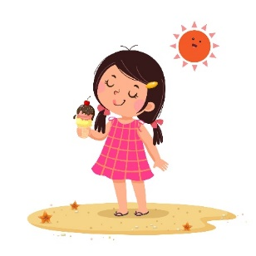
- If your child says a word incorrectly, it is better to say the word emphasising the correct sound, but without correcting the child so that conversation continues smoothly and they feel successful. Communication should be a positive experience.
Adult “You’ve got a cake- yummy!”
Child “I dot tate!”

- If you don’t understand something:
  - Repeat back the parts that you did understand. Your child will tell you if you have got it wrong! This encourages them to keep talking and gives them chance to correct you if necessary. Your child then only has to repeat the part you did not understand rather than saying the whole sentence again.
  - Encourage them to show you using actions, mime or pointing. Look at clues that might help you e.g. what have they just been doing?
  - Ask questions to help you ‘tune in’ e.g. “Are you telling me about playgroup/school?”, “Where were you?”, “Who was there?”, “What else happened?”.
- Children are all different. Some are persistent and are happy to say things a few times until you understand. Others will only say it once for you. If they give up, it can be helpful to take the blame, for example saying that “mummy is not doing very good listening today is she?”
- Set up a book with the playgroup/school. Write down things that your child might talk about e.g. names of family members or pets, favourite characters from TV, being upset about leaving their teddy at Center Parcs by mistake. The staff can also write down things that have happened to help you ‘tune in’ to what your child might tell you at the end of the day.
Our ‘General Information’ and ‘When Children Learn Sounds’ handouts can give you further help. If you are still concerned, please contact the Speech and Language Therapy Service for support.

