USING SIMPLE LANGUAGE

STRATEGIES AND ACTIVITIES TO TRY AT HOME

HOW IT HELPS
Your child learns language by hearing words and linking these to objects and actions. You can help your child by using simple language so that they can make these links more easily.
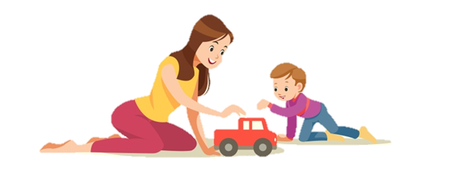
TOP TIPS
- Use a similar number of word to your child, for example, if your child is using no words or one word at a time, you should comment using one word at a time. If they are using two words at a time, you should comment using two or three words at a time.
- Children love repetition so you can use the same words over and over again.
- Talk about things that are happening now, for example, things they are playing with, looking at or doing.
- Use the most helpful word, for example, saying ‘cake’ is more useful than talking about colours, numbers or size.
- Pause after using a word to give your child time to listen and respond
- Do NOT get them to copy you.
- Get down to your child’s level so you are face to face.
HOW TO USE SIMPLE LANGUAGE
Instead of saying… | You could say…
“That’s a lovely picture of a sun you’ve drawn” | “Wow sun!”
“Look mummy bought some yummy cake for pudding” | “Look…cake”
“I found a cow” | “cow!”

